What is Entity Framework Core?
Entity Framework (EF) Core is an ORM (Object-Relational Mapper) Framework for data access in .Net. It was released along with .NET Core and is an extensible, lightweight, Open Source, and cross-platform version of Entity Framework data access technology. It works on multiple operating systems like Windows, Mac, and Linus.
What is ORM?
The term ORM stands for Object-Relational Mapper and it automatically creates classes based on database tables and the vice versa is also true. That is, it can also generate the necessary SQL to create the database based on the classes.
As a developer, we mostly work with the application business objects and the ORM Framework generates the necessary SQL (to perform the CRUD operation) that the underlying database can understand. So, in simple words, we can say that the ORM Framework eliminates the need for most of the data access code that as a developer we generally write.
Why do we need to use an ORM?
Let us understand why we need to use the ORM Framework with an example.
Suppose we want to develop an application to manage the students of a college. In order to do this, we may need to create classes such as Student, Department, Address, etc. Technically we called these classes as Domain classes.
Without using ORM Framework like Entity Framework or EF Core, we have to write lots of data access code to perform the CRUD operations i.e. store and retrieve the Student, Department and Address data from the underlying database tables.
For example, in order to perform CRUD operations i.e. read, insert, update or delete from a database table, we generally need to write custom code in our application to generate the required SQL statements which can be understood by the underlying database. Again, when we want to read the data from the database into our application, then also we have to write some custom code to map the database data to our model classes like Student, Department, Address, etc. This is a very common task as a developer for us that we do almost in every application.
An ORM Framework like Entity framework or EF Core can do all of the above for us and saves a lot of time if we provide the necessary required information to the ORM Framework. The ORM Framework sits between our application code and the Database. It eliminates the need for most of the custom data-access code that we usually write without an ORM.
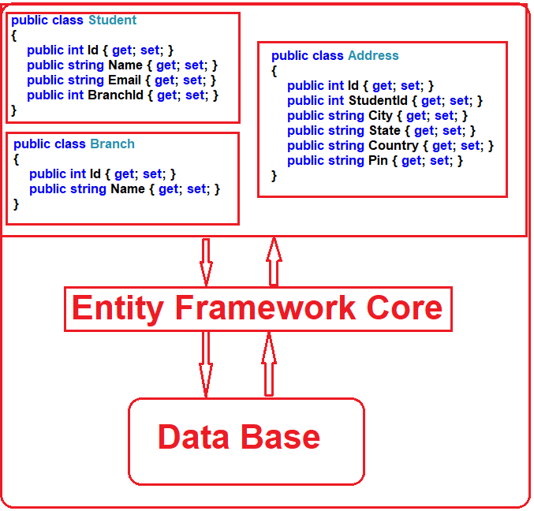
EF Core Development Approaches:
Entity Framework Core supports two development approaches. They are as follows:
- Code-First Approach
- Database-First Approach
EF Core mainly targets the code-first approach and provides little support for the database-first approach at the moment.
EF Core Code First Approach:
In the EF Core Code First Approach, first, we need to create our application domain classes such as Student, Branch, Address, etc. and a special class that derives from Entity Framework DbContext class. Then based on the application domain classes and DBContext class, the EF Core creates the database and related tables.
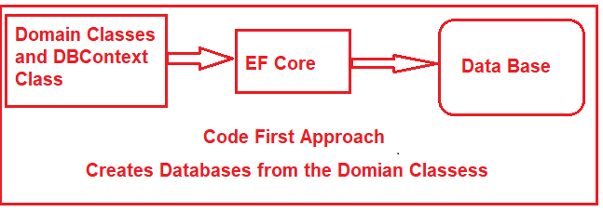
Out of the box, in the code-first approach, the EF Core API creates the database and tables using migration based on the default conventions and configuration. If you want then you can also change the default conventions used to create the database and its related tables. This approach is useful in Domain-Driven Design (DDD).
EF Core Database First Approach:
If you have an existing database and database tables are already there, then you need to use the EF Core Database First Approach. In the database-first approach, the EF Core creates the DBContext and Domain classes based on the existing database schema using EF Core Command.
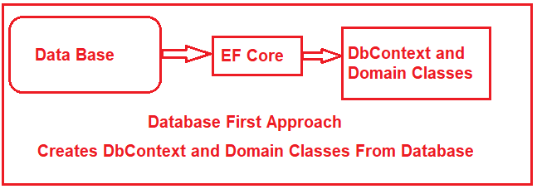
EF Core Database Providers:
The EF Core supports both relational and non-relational databases and this is possible due to database providers. The database providers are available as NuGet packages. The Database Provider sits between the EF Core and the database it supports.
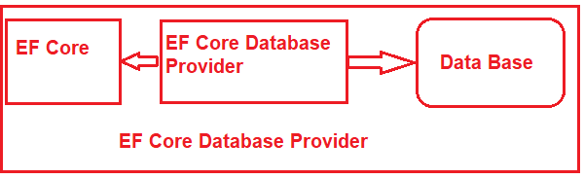
The EF Core database provider usually contains the functionality specific to the database it supports.
- Functionality that is common to all the databases is in the EF Core component.
- Functionality that is specific to a database, for example, Microsoft SQL Server-specific functionality is with-in the SQL Server provider for EF Core.
The following image shows the database providers and the NuGet packages for EF Core.
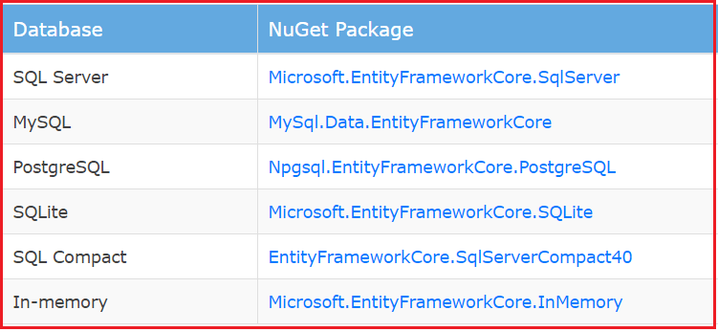
How to Install Entity Framework Core
The Entity Framework Core is not a part of the .NET Core and standard .NET framework. It is available as a NuGet Package. To use Entity Framework Core (EF Core) in .NET 8 Console Application, we need to install the following two main packages:
- EF Core DB Provider
- EF Core Tools
Entity Framework Core DB Provider:
The EF Core DB Provider Package is necessary because it allows EF Core to interact with the database. EF Core supports multiple databases, and you need to install the corresponding database provider for the database you want to use (e.g., SQL Server, SQLite, PostgreSQL, etc.). The following is the list of some of the popular databases and their corresponding EF Core Database Provider:
- Microsoft SQL Server: The NuGet Package for Microsoft SQL Server is Microsoft.EntityFrameworkCore.SqlServer
- SQLite: The NuGet Package for SQLite is Microsoft.EntityFrameworkCore.Sqlite
- MySQL: The NuGet Package for MySQL is Pomelo.EntityFrameworkCore.MySql
- PostgreSQL: The NuGet Package for PostgreSQL is Npgsql.EntityFrameworkCore.PostgreSQL

Without the EF Core Database Provider package, EF Core cannot perform database operations, as it doesn’t know how to connect and communicate with the backend database.
How to Install EF Core Database Provider:
Tools -> NuGet Package Manager -> Package Manager Console and then execute the following command:
Install-Package Microsoft.EntityFrameworkCore.SqlServer
Install-Package Microsoft.EntityFrameworkCore.Tools
DbContext Class in Entity Framework Core
The DbContext class is a core component of Entity Framework Core (EF Core) that acts as a bridge between your application’s domain (entities) classes and the underlying database. It manages database connections, performs CRUD (Create, Read, Update, Delete) operations, manages transactions, and tracks changes to entities. The DbContext class is responsible for interacting with the database using the configured database provider (e.g., SQL Server, SQLite, etc.).
What are the Methods Provided by DbContext in Entity Framework Core?
The DbContext class provides various methods to manage and interact with the database in EF Core. Some of them are as follows:
- Add/Attach/Update/Remove: Methods for adding, attaching, updating, or removing entities from the context.
- SaveChanges / SaveChangesAsync: Persists changes to the database.
- Find / FindAsync: Finds an entity by its primary key.
- Entry: Provides access to change tracking information for a specific entity.
- OnConfiguring: Allows configuring the context options (e.g., connection string) when not using dependency injection.
- AddRange/ AddRangeAsync: This function adds a collection of new entities to DbContext with the Added state and starts tracking them. The new entities will be inserted into the database when SaveChanges() or SaveChangesAsync() is called.

